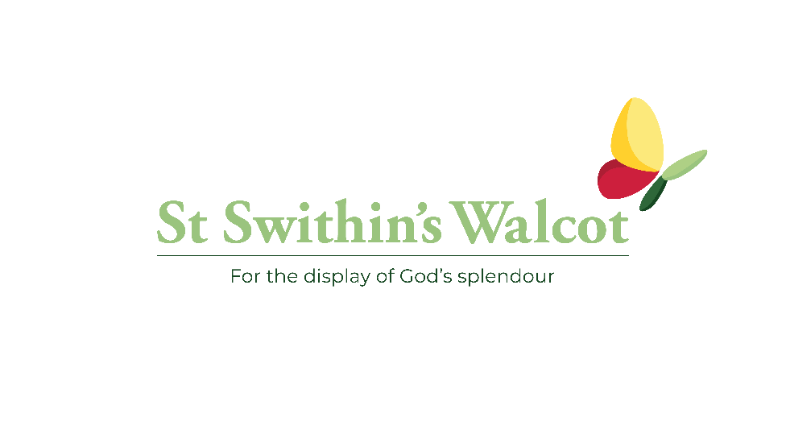
Pledge Form
- I commit to giving a regular amount of £ ………………. to the church each month.

- I commit to reviewing my existing regular giving and increase it by £……………... each month.

- I commit to making a one-off payment of £…………..…… to help reduce the deficit.

[Delete as appropriate]

Full Name ……………………………………………………………………………………….

To set up or increase a standing order, or to make a one-off donation by bank transfer, please use the bank details below.
Account: Walcot Parochial Church Council
Sort Code: 60-02-05
Account Number: 50935208
Reference: ​Giving
One-off gifts can also be made by card using the Give Online link on the St Swithins website. Our preference is bank transfer to reduce transaction fees.
Financial Giving - St Swithin's (stswithinswalcot.org.uk)

Please complete your pledge form by Sunday 30th April and confirm your financial commitment by email to treasurer@stswithinswalcot.org.uk or return your paper copy to the Church Office marked “Pledge”.

